num1=int(input("enter a number:"))

num2=int(input("enter a number:"))

try:

res=num1/num2

except Exception as ob:

print("division by zero not allowed")

else:

print(num1,'/',num2,'=',res)

print("thank u")

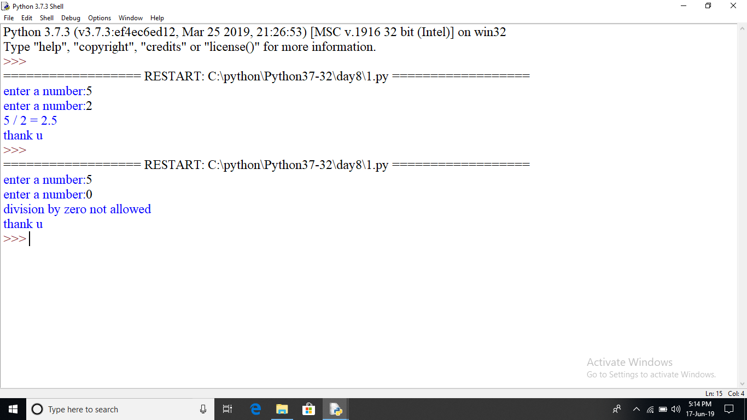

try:

import abc1

except Exception as ob:

print(ob)

num1=int(input("enter a number:"))

num2=int(input("enter a number:"))

try:

res=num1/num2

except Exception as ob:

print("division by zero not allowed")

else:

print(num1,'/',num2,'=',res)

print("thank u")

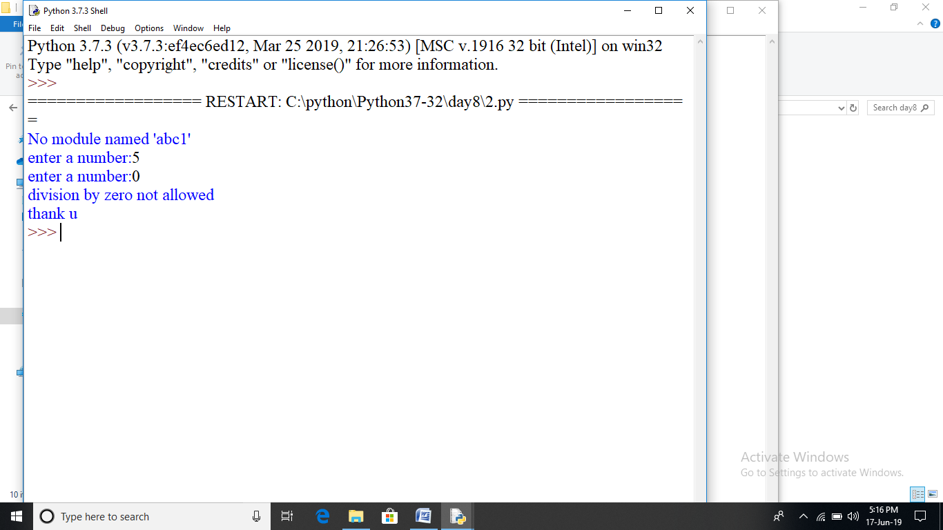

num1=int(input("enter a number:"))

num2=int(input("enter a number:"))

try:

res=num1/num2

except ZeroDivisionError as ob:

print("division by zero not allowed")

else:

print(num1,'/',num2,'=',res)

print("thank u")

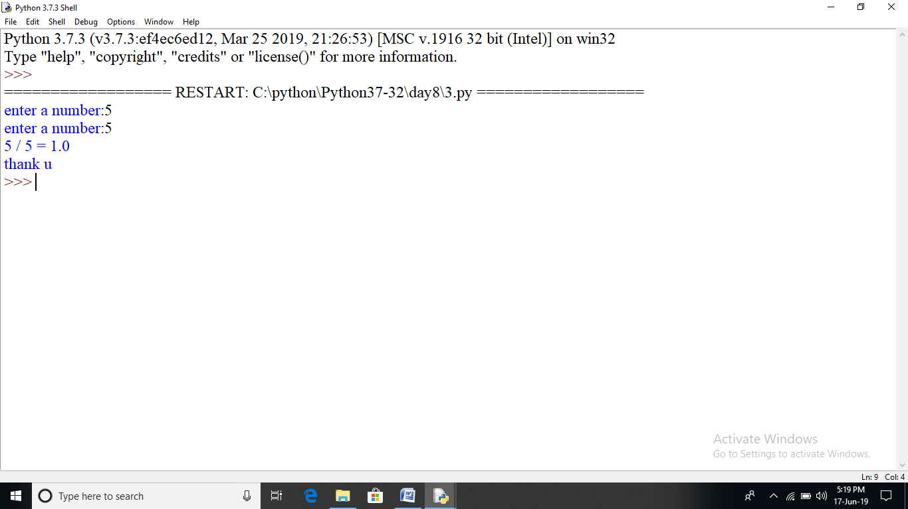

try:

num1=int(input("enter a number:"))

num2=int(input("enter a number:"))

except ValueError as ob:

print(ob)

else:

try:

res=num1/num2

except ZeroDivisionError as ob:

print("division by zero not allowed")

else:

print(num1,'/',num2,'=',res)

print("thank u")

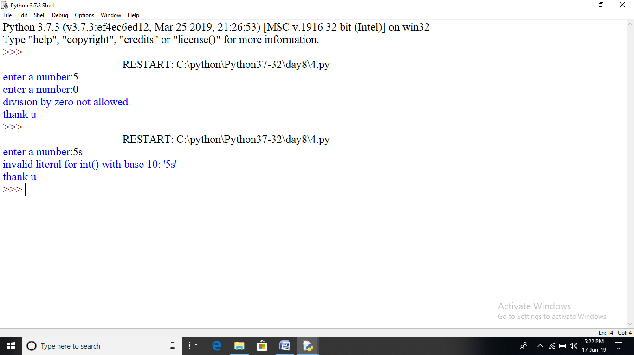

try:

num1=int(input("enter a number:"))

num2=int(input("enter a number:"))

except ValueError as ob:

print(ob)

else:

try:

res=num1/num2

except ZeroDivisionError as ob:

print("division by zero not allowed")

else:

print(num1,'/',num2,'=',res)

finally:

print("Resource deallocated")

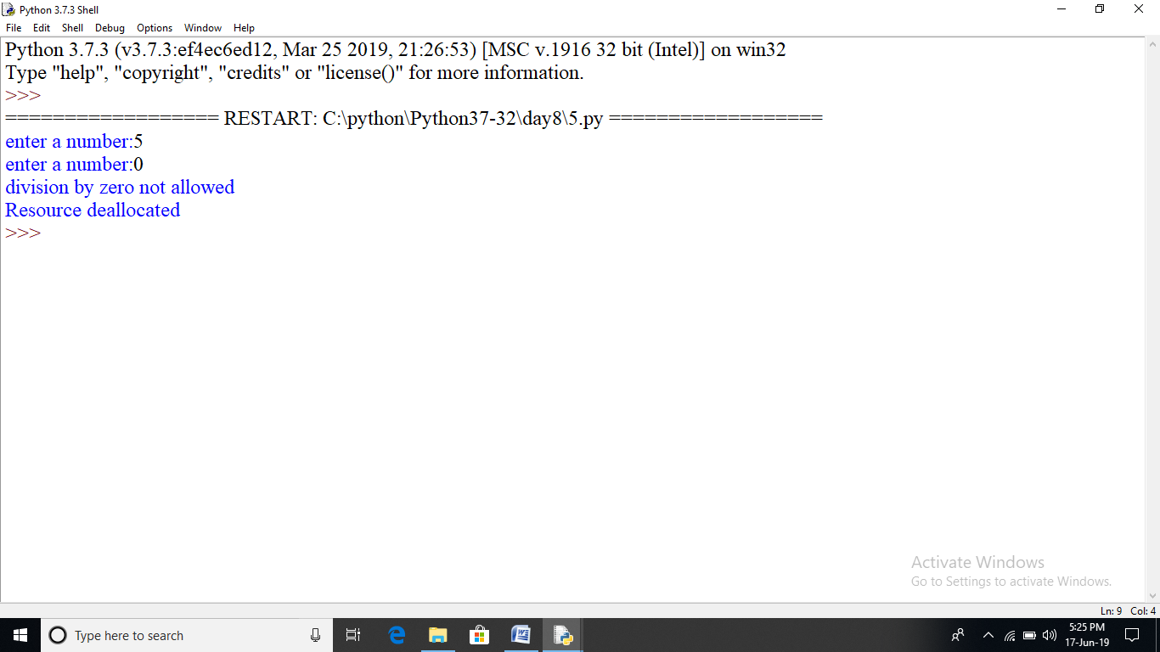

num1=(input("enter a number:"))

num2=(input("enter a number:"))

try:

res=int(num1)/int(num2)

except (ZeroDivisionError,ValueError):

print("division by zero not allowed or strings are not allowed.\

please input only integer")

except Exception as ob:

print(ob)

else:

print(num1,'/',num2,'=',res)

finally:

print("Resource deallocated")

print("visit vips again")

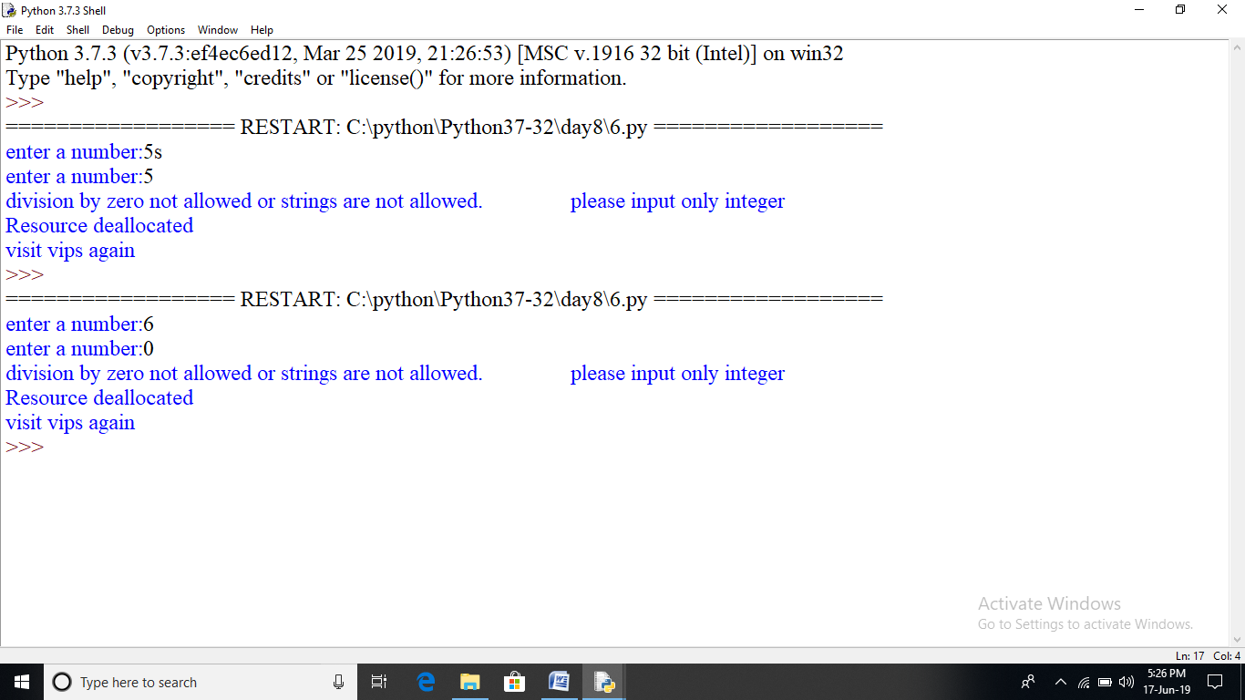

##file handling

try:

f=open(r"c:\python\student1.txt","r")

f.write("This is my test file for exception handling")

except Exception as ob:

print(ob)

finally:

print("error: can\'t file or read data")

f.close()

print("thanks")

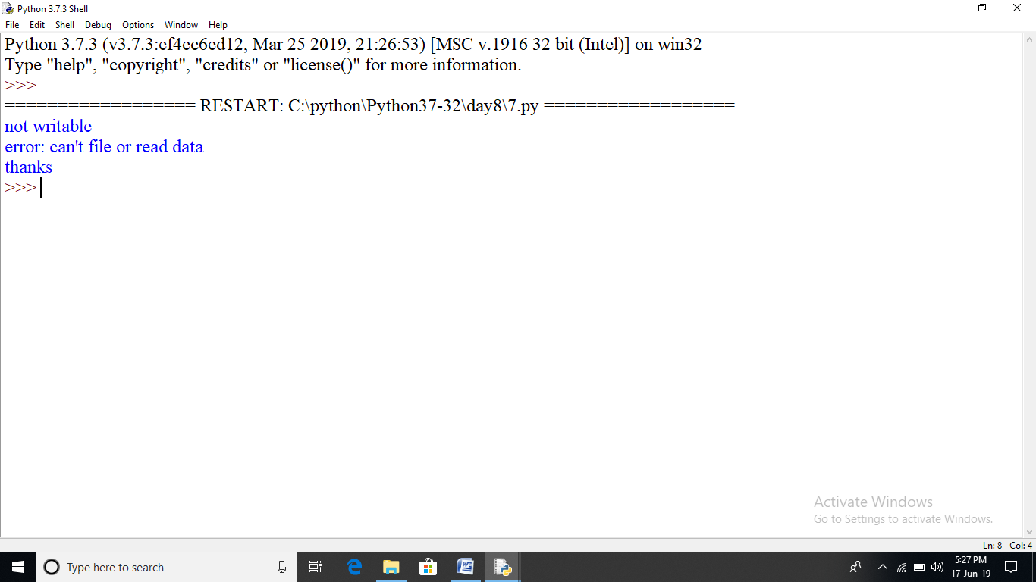

try:

f=open(r"c:\python\student1.txt","r")

f.write("This is my test file for exception handling")

except Exception as ob:

print(ob)

finally:

print("error: can\'t file or read data")

try:

f.close()

except Exception as ob:

print(ob)

print("thanks")

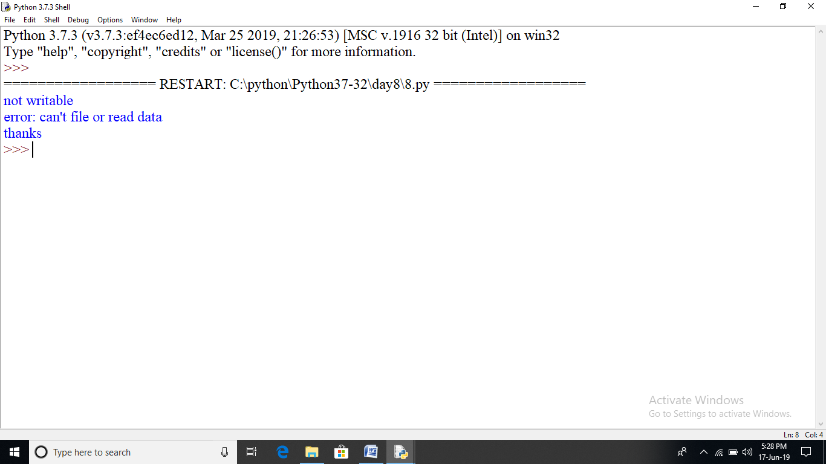

#program to perform different set operation

#define

E={2,4,6,8}

N={1,2,3,4}

print("union of E and N is ",E|N)

print("intersection of E and N is ",E&N)

print("difference of N and E is ",N-E)

print("defference of E and N is ",E-N)

print("symetric difference of E and N is ",E^N)

print("symetric difference of N and E is ",(E-N)|(N-E))

